Aim: To understand the process of convolution over the image and apply over the classification problem IDE: Google Colab Theory:
Convolutional Neural Networks (CNN) are complex feed forward neural networks. CNNs are used for image classification and recognition because of its high accuracy There are three types of layers in a convolutional neural network: i. Convolutional layer ii. Pooling layer iii. Fully connected layer Each of these layers has different parameters that can be optimized and performs a different task on the input data.

What is Pooling Layer?
Pooling layer is responsible for reducing the spatial size of the Convolved Feature. This is to decrease the computational power required to process the data through dimensionality reduction. There are two types of Pooling i. Average Pooling. ii. Max Pooling Max Pooling returns the maximum value from the portion of the image covered by the Kernel. On the other hand, Average Pooling returns the average of all the values from the portion of the image covered by the Kernel. Max Pooling also performs as a Noise Suppressant. It discards the noisy activations altogether and also performs de-noising along with dimensionality reduction. On the other hand, Average Pooling simply performs dimensionality reduction as a noise suppressing mechanism. Hence, we can say that Max Pooling performs a lot better than Average Pooling.

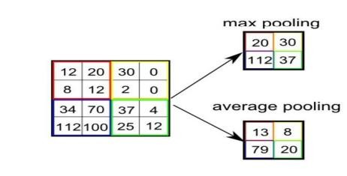

What is Convolutional Layer?
Convolutional layers are the major building blocks used in convolutional neural networks. A convolution is the simple application of a filter to an input that results in an activation. Repeated application of the same filter to an input results in a map of activations called a feature map, indicating the locations and strength of a detected feature in an input, such as an image. A convolutional layer contains a set of filters whose parameters need to be learned. The height and weight of the filters are smaller than those of the input volume. Each filter is convolved with the input volume to compute an activation map made of neurons.

What is Fully Connected Layer?
A fully connected layer that takes the output of convolution/pooling and predicts the best label to describe the image We have three layers in the full connection step i. Input layer ii. Fully-connected layer iii. Output layer

Input Layer: It takes the output of the previous layers, “flattens” them and turns them into a single vector that can be an input for the next stage.

Fully Connected Layer: It takes the inputs from the feature analysis and applies weights to predict the correct label.

Output Layer: It gives the final probabilities for each label.

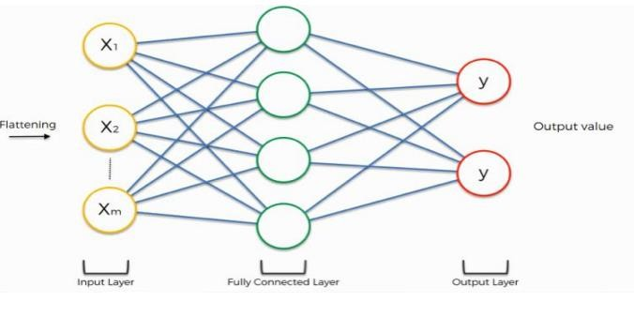

ReLU Layer: ReLU is an activation function. Rectified Linear Unit (ReLU) transform function only activates a node if the input is above a certain quantity, while the input is below zero, the output is zero, but when the input rises above a certain threshold, it has a linear relationship with the dependent variable. The main aim is to remove all the negative values from the convolution. All the positive values remain the same but all the negative values get changed to zero.

Methodology:
- Load the basic libraries and packages
- Load the dataset
- Analyse the dataset
- Normalize the data
- Pre-process the data
- Visualize the Data
- Write the CNN model function
- Write the Cost Function
- Write the Gradient Descent optimization algorithm
- Apply the training over the dataset to minimize the loss
- Observe the cost function vs iterations learning curve

Program (Code):
import tensorflow as tf
from tensorflow.keras import datasets, layers, models
import matplotlib.pyplot as plt

(X_train, y_train), (X_test, y_test) = datasets.cifar10.load_data()

X_train = X_train / 255.0
X_test = X_test / 255.0

model = models.Sequential()

model.add(layers.Conv2D(32, (3,3), activation='relu', input_shape=(32,32,3)))
model.add(layers.MaxPooling2D((2,2)))

model.add(layers.Conv2D(64, (3,3), activation='relu'))
model.add(layers.MaxPooling2D((2,2)))

model.add(layers.Flatten())
model.add(layers.Dense(64, activation='relu'))
model.add(layers.Dense(10, activation='softmax'))

model.compile(optimizer='adam',
loss='sparse_categorical_crossentropy',
metrics=['accuracy'])

history = model.fit(X_train, y_train, epochs=5,
validation_data=(X_test, y_test))

test_loss, test_acc = model.evaluate(X_test, y_test)
print("Test Accuracy:", test_acc)

plt.plot(history.history['accuracy'])
plt.plot(history.history['val_accuracy'])
plt.title("Accuracy Graph")
plt.xlabel("Epochs")
plt.ylabel("Accuracy")
plt.legend(['Train','Validation'])
plt.show()

plt.plot(history.history['loss'])
plt.plot(history.history['val_loss'])
plt.title("Loss Graph")
plt.xlabel("Epochs")
plt.ylabel("Loss")
plt.legend(['Train','Validation'])
plt.show()

Results:
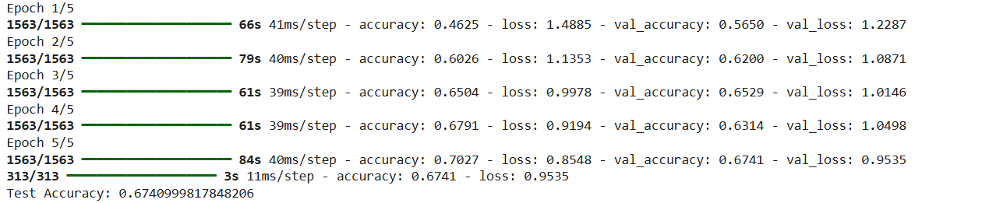

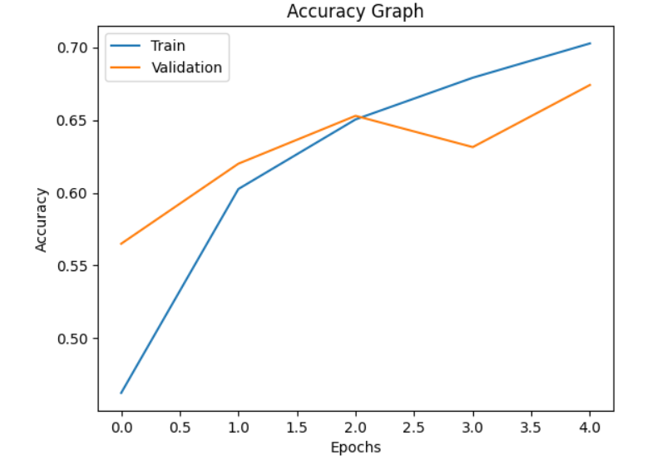

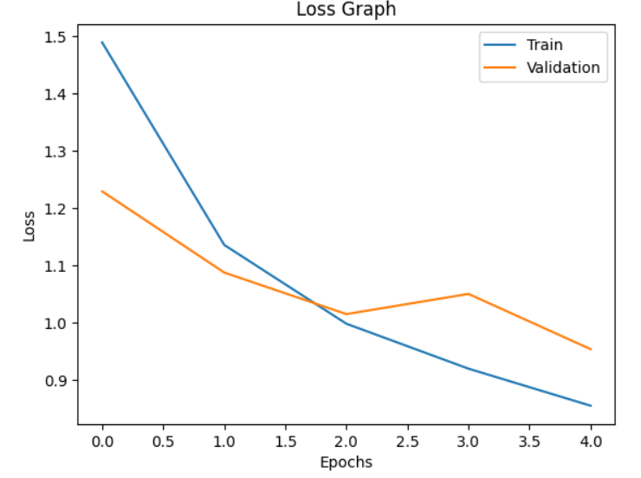

Pre Lab Exercise:

- What is Convolution process? Explain giving example.

Convolution is the process of applying a filter (kernel) over an image to extract important features like edges, patterns, or textures.
- A small matrix (kernel) slides over the image
- Multiplication and addition are performed
- Output is a feature map

Example:
A 3×3 filter applied on an image can detect edges by highlighting intensity changes.
- What are different layers in CNN model?
The main layers in CNN are:
- Convolutional Layer – extracts features
- Pooling Layer – reduces size of feature maps
- Fully Connected Layer – performs classification
Additional:
- ReLU Layer – activation function

- What is the requirement of the pooling layer in the CNN model?
Pooling layer is used to:
- Reduce the dimension (size) of feature maps
- Decrease computational cost
- Remove noise
- Improve efficiency
Types:
- Max Pooling
- Average Pooling

- What is the requirement of the use of ReLU activation function after convolution step?
ReLU is used to:
- Convert negative values into zero
- Add non-linearity
- Improve model performance
- Speed up training
It keeps positive values unchanged and removes negative values.

Observation and Result Analysis:
- Nature of the dataset
The dataset consists of colored images (32×32 pixels) belonging to multiple classes (CIFAR-10).
It is a multi-class classification problem, where each image belongs to one category like car, cat, etc.

- Training Process without regularization
- The model learns features using convolution layers
- Training accuracy increases with epochs
- Validation accuracy may fluctuate
- Model may overfit (high training accuracy, lower validation accuracy)

- After regularization in the training Process
- Overfitting reduces
- Training and validation accuracy become closer
- Model generalizes better
- Stability improves

- Observation over the Learning Curves
- Accuracy curve increases over epochs
- Loss curve decreases gradually
- Gap between training & validation indicates overfitting
- Proper regularization improves curves

Post Lab Exercise:
- Why CNN is preferred over ANN for images
- CNN captures spatial features (edges, shapes)
- Uses fewer parameters
- More accurate for image tasks

- Can CNN be applied over Text data? If yes, then how. If no, then why?
Yes, CNN can be used for text:
- Words are converted into vectors (embeddings)
- CNN extracts patterns from sequences
- Used in sentiment analysis and NLP tasks

- What is the role of dropout layer?

- Randomly disables neurons during training
- Prevents overfitting
- Improves generalization

d. What will happen if maxpooling is replaced with minpooling?
- Important features may be lost
- Noise may increase
- Performance decreases
- Model becomes less effective

